2017 Mock Newbery List

Booked by Kwame Alexander
Like lightning/you strike/fast and free/legs zoom/down field/eyes fixed/on the checkered ball/on the goal/ten yards to go/can’t nobody stop you/
can’t nobody cop you…
In this follow-up to the Newbery-winning novel THE CROSSOVER, soccer, family, love, and friendship, take center stage as twelve-year-old Nick learns the power of words as he wrestles with problems at home, stands up to a bully, and tries to impress the girl of his dreams. Helping him along are his best friend and sometimes teammate Coby, and The Mac, a rapping librarian who gives Nick inspiring books to read. This electric and heartfelt novel-in-verse by poet Kwame Alexander bends and breaks as it captures all the thrills and setbacks, action and emotion of a World Cup match!

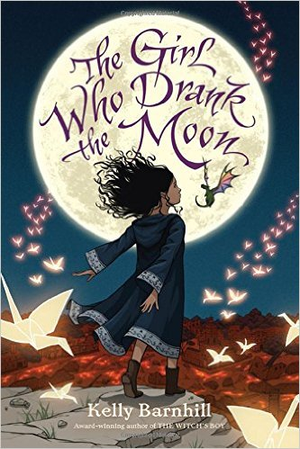
The Girl who Drank the Moon by Kelly Barnhill
Every year, the people of the Protectorate leave a baby as an offering to the witch who lives in the forest. They hope this sacrifice will keep her from terrorizing their town. But the witch in the Forest, Xan, is kind. She shares her home with a wise Swamp Monster and a Perfectly Tiny Dragon. Xan rescues the children and delivers them to welcoming families on the other side of the forest, nourishing the babies with starlight on the journey.One year, Xan accidentally feeds a baby moonlight instead of starlight, filling the ordinary child with extraordinary magic. Xan decides she must raise this girl, whom she calls Luna, as her own. As Luna’s thirteenth birthday approaches, her magic begins to emerge--with dangerous consequences. Meanwhile, a young man from the Protectorate is determined to free his people by killing the witch. Deadly birds with uncertain intentions flock nearby. A volcano, quiet for centuries, rumbles just beneath the earth’s surface. And the woman with the Tiger’s heart is on the prowl . . The author of the highly acclaimed, award-winning novel The Witch’s Boy has written an epic coming-of-age fairy tale destined to be a modern classic.

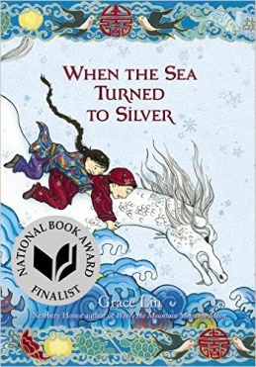
When the Sea Turned to Silver by Grace Lin
Pinmei's gentle, loving grandmother always has the most exciting tales for her granddaughter and the other villagers. However, the peace is shattered one night when soldiers of the Emperor arrive and kidnap the storyteller.Everyone knows that the Emperor wants something called the Luminous Stone That Lights the Night. Determined to have her grandmother returned, Pinmei embarks on a journey to find the Luminous Stone alongside her friend Yishan, a mysterious boy who seems to have his own secrets to hide.Together, the two must face obstacles usually found only in legends to find the Luminous Stone and save Pinmei's grandmother before it's too late. A fast-paced adventure that is extraordinarily written and beautifully illustrated, When the Sea Turned to Silver is a masterpiece companion novel to Where the Mountain Meets the Moon and Starry River of the Sky.

As Brave as You by Jason Reynolds
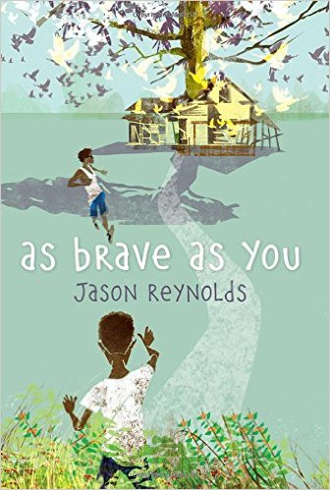
Genie’s summer is full of surprises. The first is that he and his big brother, Ernie, are leaving Brooklyn for the very first time to spend the summer with their grandparents all the way in Virginia --- in the COUNTRY! The second surprise comes when Genie figures out that their grandfather is blind. Thunderstruck and --- being a curious kid --- Genie peppers Grandpop with questions about how he covers it so well (besides wearing way cool Ray-Bans). How does he match his clothes? Know where to walk? Cook with a gas stove? Pour a glass of sweet tea without spilling it? Genie thinks Grandpop must be the bravest guy he’s ever known, but he starts to notice that his grandfather never leaves the house --- as in NEVER. And when he finds the secret room that Grandpop is always disappearing into --- a room so full of songbirds and plants that it’s almost as if it’s been pulled inside-out --- he begins to wonder if his grandfather is really so brave after all. Then Ernie lets him down in the bravery department. It’s his fourteenth birthday, and, Grandpop says to become a man, you have to learn how to shoot a gun. Genie thinks that is AWESOME until he realizes Ernie has no interest in learning how to shoot. None. Nada. Dumbfounded by Ernie’s reluctance, Genie is left to wonder --- is bravery and becoming a man only about proving something, or is it just as important to own up to what you won’t do?

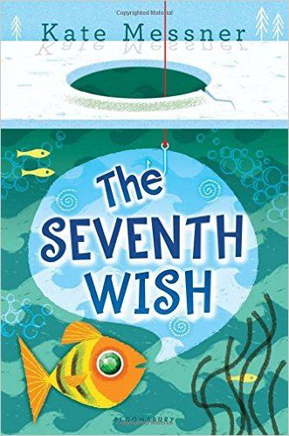
The Seventh Wish by Kate Messner
Charlie feels like she's always coming in last. From her Mom's new job to her sister's life away at college, everything else always seems to be more important than Charlie's upcoming dance competition or science project. Unsure of how to get her family's attention, Charlie comes across the surprise of her life one day while ice-fishing . . . in the form of a floppy, scaly fish offering to grant her a wish in exchange for its freedom. Charlie can't believe her luck until she realizes that this fish has a funny way of granting wishes, despite her best intentions. But when her family faces a challenge bigger than any they've ever experienced, Charlie wonders if some things might be too important to risk on a wish. With the same warmth and fun that readers loved in All the Answers, Kate Messner weaves fantasy into the ordinary, giving every reader the opportunity to experience a little magic.

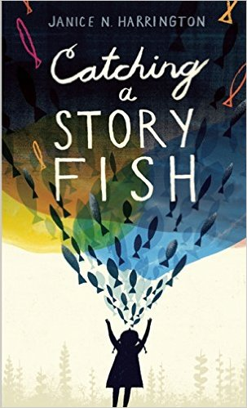
Catching a Storyfish by Janice Harrington
Keet knows the only good thing about moving away from her Alabama home is that she’ll live near her beloved grandfather. When Keet starts school, it’s even worse than she expected, as the kids tease her about her southern accent. Now Keet, who can “talk the whiskers off a catfish,” doesn’t want to open her mouth. Slowly, though, while fishing with her grandfather, she learns the art of listening. Gradually, she makes her first new friend. But just as she’s beginning to settle in, her grandfather has a stroke, and even though he’s still nearby, he suddenly feels ever-so-far-away. Keet is determined to reel him back to her by telling him stories; in the process she finds her voice and her grandfather again. This lyrical and deeply emotional novel-in-verse celebrates the power of story and of finding one’s individual voice.

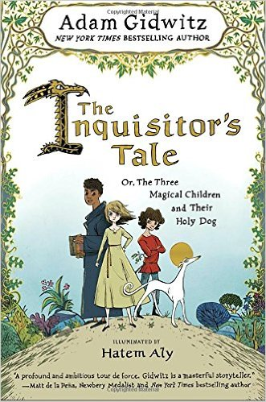
The Inquisitor's Tale: Or, The Three Magical Children and Their Holy Dog by Adam Gidwitz, illustrated by Hatem Aly
1242. On a dark night, travelers from across France cross paths at an inn and begin to tell stories of three children. Their adventures take them on a chase through France: they are taken captive by knights, sit alongside a king, and save the land from a farting dragon. On the run to escape prejudice and persecution and save precious and holy texts from being burned, their quest drives them forward to a final showdown at Mont Saint-Michel, where all will come to question if these children can perform the miracles of saints.
Join William, an oblate on a mission from his monastery; Jacob, a Jewish boy who has fled his burning village; and Jeanne, a peasant girl who hides her prophetic visions. They are accompanied by Jeanne's loyal greyhound, Gwenforte . . . recently brought back from the dead. Told in multiple voices, in a style reminiscent of The Canterbury Tales, our narrator collects their stories and the saga of these three unlikely allies begins to come together. Beloved bestselling author Adam Gidwitz makes his long awaited return with his first new world since his hilarious and critically acclaimed Grimm series. Featuring manuscript illuminations throughout by illustrator Hatem Aly and filled with Adam’s trademark style and humor, The Inquisitor's Tale is bold storytelling that’s richly researched and adventure-packed.

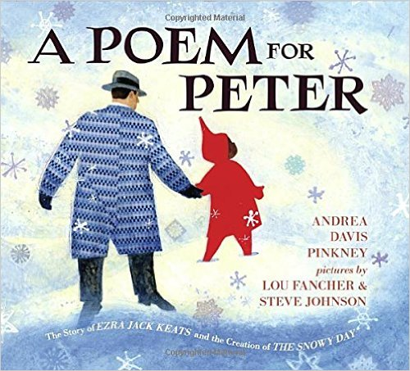
A Poem for Peter: The Story of Ezra Jack Keats and the Creation of The Snowy Day by Andrea Davis Pinkney, illustrated by Steve Johnson and Lou Fancher
The story of The Snowy Day begins more than one hundred years ago, when Ezra Jack Keats was born in Brooklyn, N.Y. The family were struggling Polish immigrants, and despite Keats’s obvious talent, his father worried that Ezra’s dream of being an artist was an unrealistic one. But Ezra was determined. By high school he was winning prizes and scholarships. Later, jobs followed with the WPA and Marvel comics. But it was many years before Keats’s greatest dream was realized and he had the opportunity to write and illustrate his own book. For more than two decades, Ezra had kept pinned to his wall a series of photographs of an adorable African American child. In Keats’s hands, the boy morphed into Peter, a boy in a red snowsuit, out enjoying the pristine snow; the book became The Snowy Day, winner of the Caldecott Medal, the first mainstream book to feature an African American child. It was also the first of many books featuring Peter and the children of his — and Keats’s — neighborhood. Andrea Davis Pinkney’s lyrical narrative tells the inspiring story of a boy who pursued a dream, and who, in turn, inspired generations of other dreamers.

