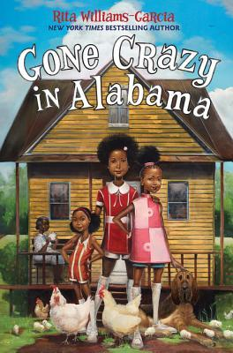
Gone Crazy in Alabama
By: Rita Williams-Garcia
Newbery Honor winner and New York Times bestselling author Rita Williams-Garcia tells the story of the Gaither sisters, who are about to learn what it's like to be fish out of water as they travel from the streets of Brooklyn to the rural South for the summer of a lifetime. Delphine, Vonetta, and Fern are off to Alabama to visit their grandmother, Big Ma, and her mother, Ma Charles. Across the way lives Ma Charles's half sister, Miss Trotter. The two half sisters haven't spoken in years. As Delphine hears about her family history, she uncovers the surprising truth that's been keeping the sisters apart. But when tragedy strikes, Delphine discovers that the bonds of family run deeper than she ever knew possible.

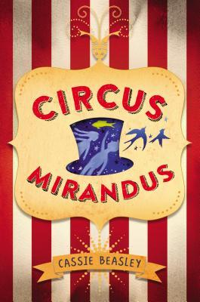
Circus Mirandus
By: Cassie Beasley
Do you believe in magic? Micah Tuttle does. Even though his awful Great-Aunt Gertrudis doesn’t approve, Micah believes in the stories his dying Grandpa Ephraim tells him of the magical Circus Mirandus: the invisible tiger guarding the gates, the beautiful flying birdwoman, and the magician more powerful than any other—the Man Who Bends Light. Finally, Grandpa Ephraim offers proof. The Circus is real. And the Lightbender owes Ephraim a miracle. With his friend Jenny Mendoza in tow, Micah sets out to find the Circus and the man he believes will save his grandfather.
The only problem is, the Lightbender doesn't want to keep his promise. And now it's up to Micah to get the miracle he came for.

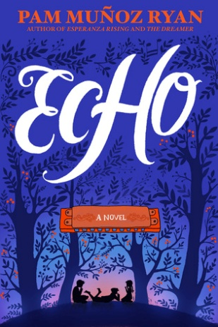
Echo
By: Pam Muñoz Ryan
Music, magic, and a real-life miracle meld in this genre-defying masterpiece from storytelling maestro Pam Muñoz Ryan. Lost and alone in a forbidden forest, Otto meets three mysterious sisters and suddenly finds himself entwined in a puzzling quest involving a prophecy, a promise, and a harmonica. Decades later, Friedrich in Germany, Mike in Pennsylvania, and Ivy in California each, in turn, become interwoven when the very same harmonica lands in their lives. All the children face daunting challenges: rescuing a father, protecting a brother, holding a family together. And ultimately, pulled by the invisible thread of destiny, their suspenseful solo stories converge in an orchestral crescendo. Richly imagined and masterfully crafted, ECHO pushes the boundaries of genre and form, and shows us what is possible in how we tell stories. The result is an impassioned, uplifting, and virtuosic tour de force that will resound in your heart long after the last note has been struck.
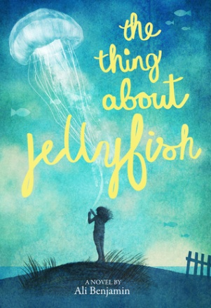
The Thing About Jellyfish
By: Ali Benjamin
After her best friend dies in a drowning accident, Suzy is convinced that the true cause of the tragedy must have been a rare jellyfish sting-things don't just happen for no reason. Retreating into a silent world of imagination, she crafts a plan to prove her theory--even if it means traveling the globe, alone. Suzy's achingly heartfelt journey explores life, death, the astonishing wonder of the universe...and the potential for love and hope right next door.
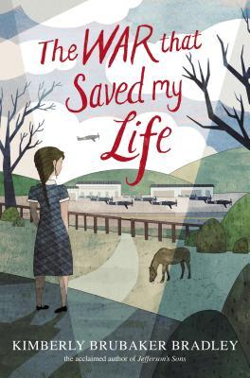
The War That Saved My Life
By: Kimberly Brubaker Bradley
Nine-year-old Ada has never left her one-room apartment. Her mother is too humiliated by Ada’s twisted foot to let her outside. So when her little brother Jamie is shipped out of London to escape the war, Ada doesn’t waste a minute—she sneaks out to join him. So begins a new adventure of Ada, and for Susan Smith, the woman who is forced to take the two kids in. As Ada teaches herself to ride a pony, learns to read, and watches for German spies, she begins to trust Susan—and Susan begins to love Ada and Jamie. But in the end, will their bond be enough to hold them together through wartime? Or will Ada and her brother fall back into the cruel hands of their mother?

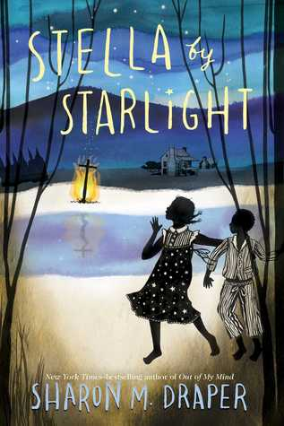
Stella by Starlight
By: Sharon Draper
When the Ku Klux Klan's unwelcome reappearance rattles Stella's segregated southern town, bravery battles prejudice in this Depression-era tour de force from Sharon Draper, the New York Times bestselling author of Out of My Mind. Stella lives in the segregated South; in Bumblebee, North Carolina, to be exact about it. Some stores she can go into. Some stores she can't. Some folks are right pleasant. Others are a lot less so. To Stella, it sort of evens out, and heck, the Klan hasn't bothered them for years. But one late night, later than she should ever be up, much less wandering around outside, Stella and her little brother see something they're never supposed to see, something that is the first flicker of change to come, unwelcome change by any stretch of the imagination. As Stella's community - her world - is upended, she decides to fight fire with fire. And she learns that ashes don't necessarily signify an end.

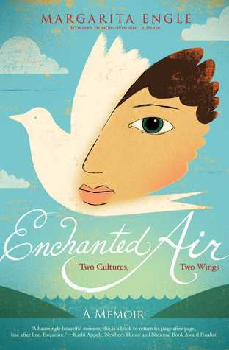
Enchanted Air
By: Margarita Engle
Margarita is a girl from two worlds. Her heart lies in Cuba, her mother's tropical island country, a place so lush with vibrant life that it seems like a fairy tale kingdom. But most of the time she lives in Los Angeles, lonely in the noisy city and dreaming of the summers when she can take a plane through the enchanted air to her beloved island. Words and images are her constant companions, friendly and comforting when the children at school are not. Then a revolution breaks out in Cuba. Margarita fears for her far-away family. When the hostility between Cuba and the United States erupts at the Bay of Pigs Invasion, Margarita's worlds collide in the worst way possible. How can the two countries she loves hate each other so much? And will she ever get to visit her beautiful island again?

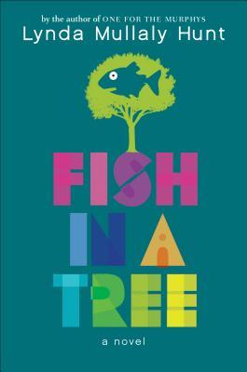
Fish in a Tree
By: Lynda Mullaly Hunt
“Everybody is smart in different ways. But if you judge a fish by its ability to climb a tree, it will live its life believing it is stupid.”Ally has been smart enough to fool a lot of smart people. Every time she lands in a new school, she is able to hide her inability to read by creating clever yet disruptive distractions. She is afraid to ask for help; after all, how can you cure dumb? However, her newest teacher Mr. Daniels sees the bright, creative kid underneath the trouble maker. With his help, Ally learns not to be so hard on herself and that dyslexia is nothing to be ashamed of. As her confidence grows, Ally feels free to be herself and the world starts opening up with possibilities. She discovers that there’s a lot more to her—and to everyone—than a label, and that great minds don’t always think alike.

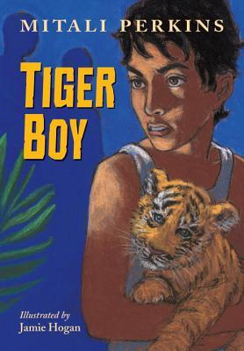
Tiger Boy
By: Mitali Perkins
“One of the new tiger cubs has escaped from the reserve!”When a tiger cub escapes from a nature reserve near Neel’s island village, the rangers and villagers hurry to find her before the cub’s anxious mother follows suit and endangers them all. Mr. Gupta, a rich newcomer to the island, is also searching—he wants to sell the cub’s body parts on the black market. Neel and his sister, Rupa, resolve to find the cub first and bring her back to the reserve where she belongs. The hunt for the cub interrupts Neel’s preparations for an exam to win a prestigious scholarship at a boarding school far from home. Neel doesn’t mind—he dreads the exam and would rather stay on his beloved island in the Sunderbans of West Bengal with his family and friends. But through his encounter with the cub, Neil learns that sometimes you have to take risks to preserve what you love. And sometimes you have to sacrifice the present for the chance to improve the future.

The Boys Who Challenged Hitler
By: Phillip Hoose
At the outset of World War II, Denmark did not resist German occupation. Deeply ashamed of his nation’s leaders, fifteen-year-old Knud Pedersen resolved with his brother and a handful of schoolmates to take action against the Nazis if the adults would not. Naming their secret club after the fiery British leader, the young patriots in the Churchill Club committed countless acts of sabotage, infuriating the Germans, who eventually had the boys tracked down and arrested. But their efforts were not in vain: the boys' exploits and eventual imprisonment helped spark a full-blown Danish resistance. Interweaving his own narrative with the recollections of Knud himself, here is Phil Hoose's inspiring story of these young war heroes.

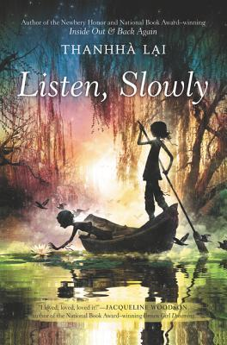
Listen Slowly
By: Thanhha Lai
A California girl born and raised, Mai can't wait to spend her vacation at the beach. Instead, though, she has to travel to Vietnam with her grandmother, who is going back to find out what really happened to her husband during the Vietnam War. Mai's parents think this trip will be a great opportunity for their out-of-touch daughter to learn more about her culture. But to Mai, those are their roots, not her own. Vietnam is hot, smelly, and the last place she wants to be. Besides barely speaking the language, she doesn't know the geography, the local customs, or even her distant relatives. To survive her trip, Mai must find a balance between her two completely different worlds. Perfect for fans of Rita Williams-Garcia and Linda Sue Park, Listen, Slowly is an irresistibly charming and emotionally poignant tale about a girl who discovers that home and culture, family and friends, can all mean different things.
Roller Girl
By: Victoria Jamieson
Twelve-year-old Astrid has always done everything with her best friend Nicole. So when Astrid signs up for roller derby camp, she assumes Nicole will too. But Nicole signs up for dance camp with a new friend instead, and so begins the toughest summer of Astrid's life. There are bumps and bruises as Astrid learns who she is without Nicole...and what it takes to be a strong, tough roller girl.

